INFS1200/7900 Module 1 Assignment

Due: 28 August 2020 @ 11:59 PM

Weighting: 10%
 | Full Name | Student ID
Group Member 1 | Xianglong LIN | 45791439
Group Member 2 | Jinghui WANG | 45739178

Overview
The purpose of this assignment is to test your ability to use conceptual modelling, such as ER and EER diagrams, to capture important aspects of a system which need to be stored in a database.

This assignment can be completed either in groups of two or individually.

Submission
All submissions must be made through an electronic marking tool called Gradescope, which will also be used for providing feedback. You must record all your answers in the spaces provided in this document. Altering the format or layout of this document in anyway will attract penalties. You may however add landscape images in the submission boxes without changing the orientation of the page.

All submissions must have the above boxes filled out in order to be identified. For students working in groups, submissions should be made by ONE team member only. Extra submissions will attract penalties.

Marking
The Module 1 assignment is worth 10 course marks (of 40 course marks total for all four assignments).

Plagiarism
The University has strict policies regarding plagiarism. Penalties for engaging in unacceptable behaviour can range from cash fines or loss of grades in a course, through to expulsion from UQ. You are required to read and understand the policies on academic integrity and plagiarism in the course profile (Section 6.1).

If you have any questions regarding acceptable level of collaboration with your peers, please see either the lecturer or your tutor for guidance. Remember that ignorance is not a defence!

Task
This assignment contains four different sections. Each section will contain a brief UoD providing contextual information regarding a system or organisation. For each section you will need to create an Entity Relational (ER) diagram or Extended Entity Relational (EER) diagram based on the UoD.

If the UoD is unclear regarding specific aspects of the brief you may note assumptions on your ER diagram. However, please beware that your assumptions must not conflict with or violate any aspects of the UoD.

Section A – QLD’s Vaccine Program
As part of the QLD Government’s fight against COVID-19 they have commissioned you to work with Queensland Health to develop a new database system which tracks patient vaccinations.

Each patient in the system is identified by their Medicare number. In addition to this, their first name, last name and address (unit number, house number, street name, suburb, postcode) are recorded. Any allergies of the patient are also stored for safety purposes.

For each vaccine, the name of the vaccine, a brief description of the vaccine and the cost of the vaccine are recorded. The name of each vaccine is unique. Vaccines must have a safety classification. Each safety classification has a unique code, a description and a list of possible side effects. Several vaccines can have the same safety classification. QLD health does not record the information of any vaccines with safety classification “MX3”.

Patients can be administered several vaccines and a vaccine can be given to several patients. Some vaccines, however, may still be undergoing human trials and as such are not administered to patients. This system will only record patients who have been administered a vaccine.
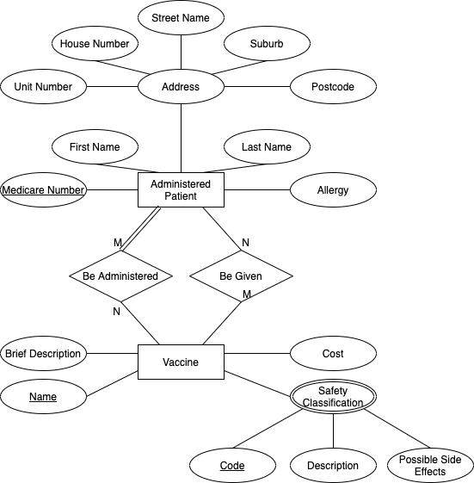

Section B – Royal Luggage
The royal family likes things just so. As such, it is of utmost importance that when they travel their luggage is not lost or misplaced. To assist in both managing and tracking the strenuous task of organising royal luggage, the Queen herself has formally requested you design a database system which can track the royal family’s luggage. She has outlined the specification of this system below.

Each royal family member is identified by either a unique ID number or their full name which is made up of a first name, last name and suffix (e.g. I, II, Sr., Jr.). Their date of birth, email address and WhatsApp ID are also recorded. A trip, which is identified by its name, also contains a trip description, destination, itinerary and a number indicating the cost.

A royal family member will pack luggage for various trips. Each piece of their luggage for each trip is labelled sequentially with a number beginning from one. Thus, a piece of luggage can only be identified with respect to both the family member who packed it and the trip the luggage will be taken on. In addition, the size and colour of the bag are recorded along with each item which is in that piece of luggage.

Sometimes, however, a royal family member may not be able to complete a trip. In this case, the date they returned home from the trip and the reason for their return is recorded for the Queen’s personal review later.
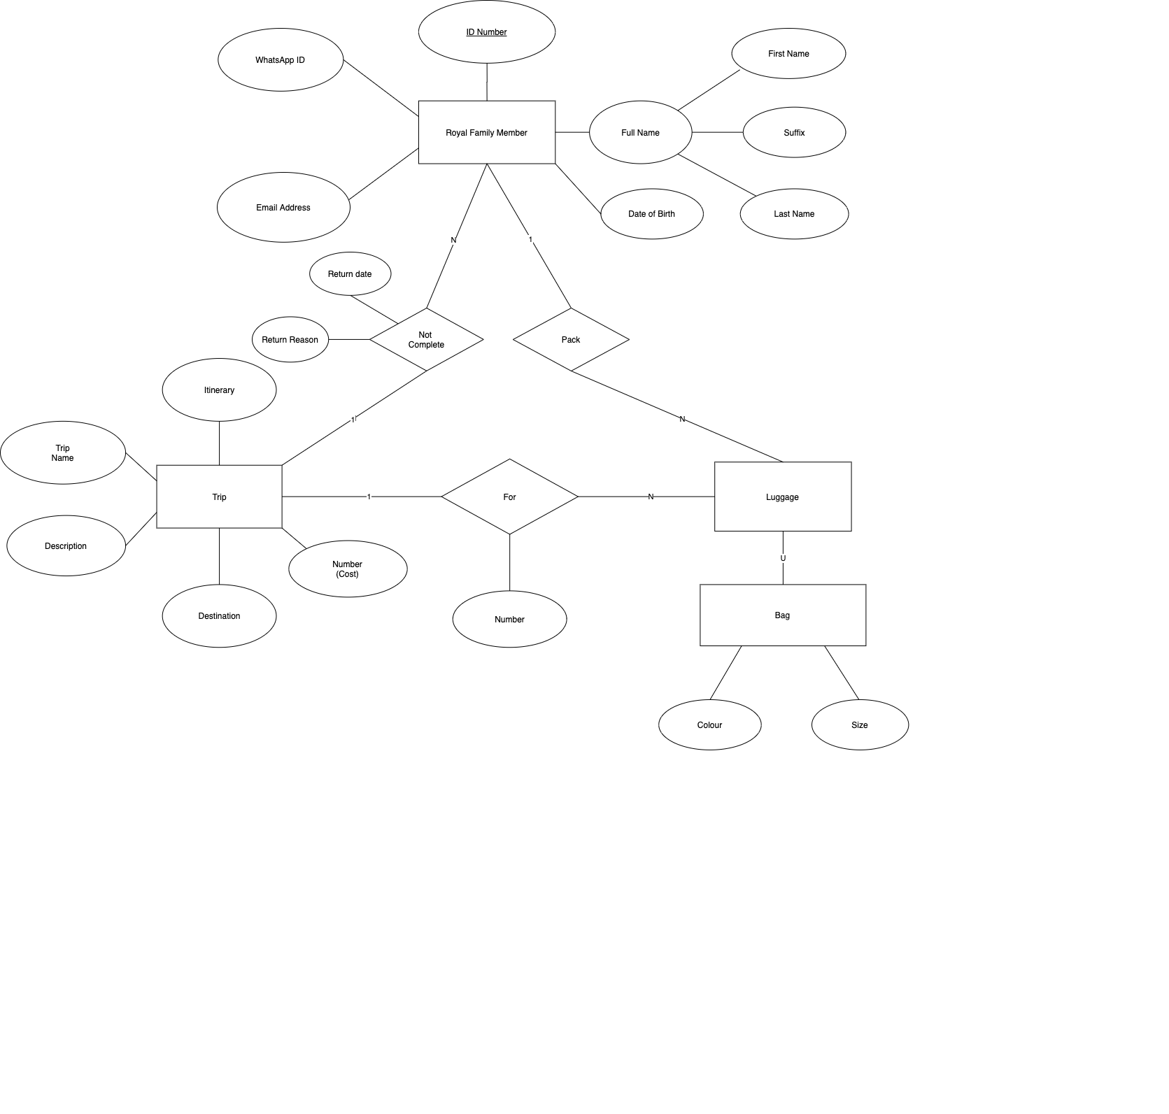

Section C - Burnouts at Bathurst
In order to increase the audience engagement at the yearly Bathurst competition, the race organisers have approved a new program allowing patron to race specially modified Honda Civics around the track after hours. For insurance purposes however, all the information regarding these activities must be logged in a database.

Each patron is identified by either their full name (first name, middle initial, last name) or their driver’s licence. The home address, phone number and any previous traffic infringements are also recorded. Each patron can select one modified Honda Civic as their favourite car.

For each modified Honda Civic, their unique serial number is recorded along with the number of seats, whether it is an automatic or manual, the last service date and if it is NOS enabled. There are three types of Honda Civics which are used, the Hatchback, the Coupé and the Sedan. For the hatchback, the rim type and brake calliper colour are also recorded. Additionally, for each Sedan the seat type is recorded.

All staff at the Bathurst Race are identified with a StaffID but their first name, last name and phone number are also recorded. Some staff members are also race instructors for which their number of years’ experience is recorded.

Each racing session includes a patron, race instructor and modified Honda Civic. The fastest lap time of each session is recorded along with a unique session timestamp.
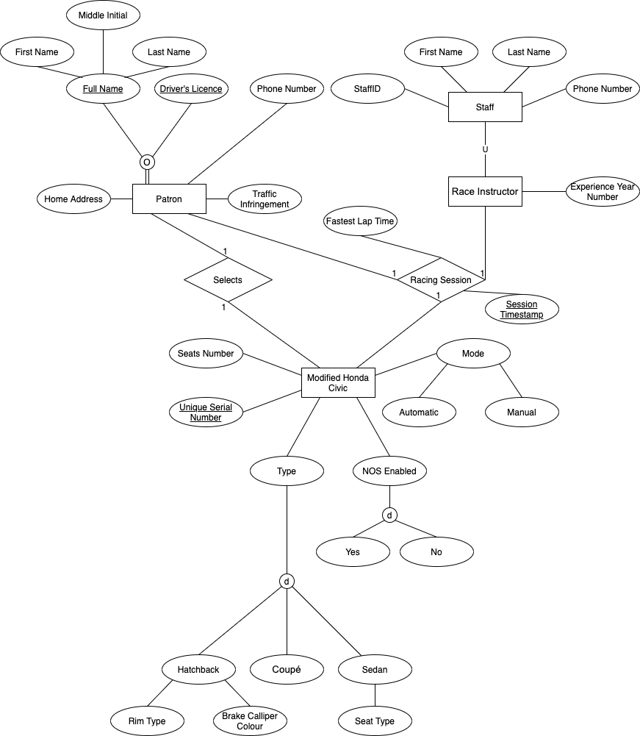

Section D – Pear Inc.
Daniel has decided to design a ground-breaking new series of laptops and mobile phones with the brand name “Pear”. In his enthusiasm to revolutionise the IT industry, Daniel discovered that he has been losing track of all the new devices he invented, and the parts associated with them. As such, he wants you to create a database system to track his new creations.

Each device Daniel creates has a unique product name and a unique product ID. In addition to this, a brief description along with a recommended retail value are recorded. Devices fall into two distinct categories, mobile phones and laptops. For mobile phones, the screen size is recorded along with the camera quality and whether or not it has a headphone jack. For laptops however, the battery life, keyboard style and graphics card are stored.

Each device can have several parts. A part has a unique name and a unique part number. However, because a part may be used in several devices, parts can only be identified with respect to the specific device they are used in. The warranty, weight and technical description for each part is also recorded. Several parts may connect with each other in a device. The connection type between each of these parts is also stored.

Daniel has assigned several beta testers to try out the initial prototypes for his laptop range. For each beta tester, their first name, last name, phone number(s) and email addresses(s) are recorded along with their unique tester ID. They review each laptop once and submit a rating out of 10 in addition to a small text response.
